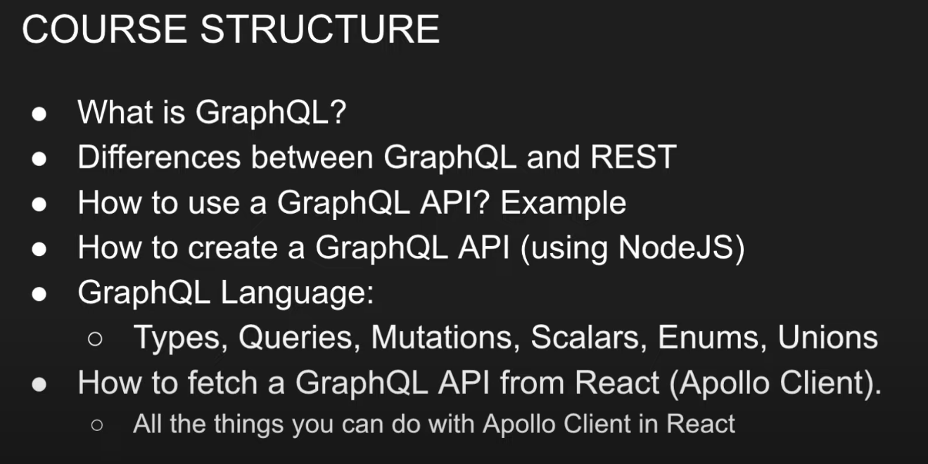

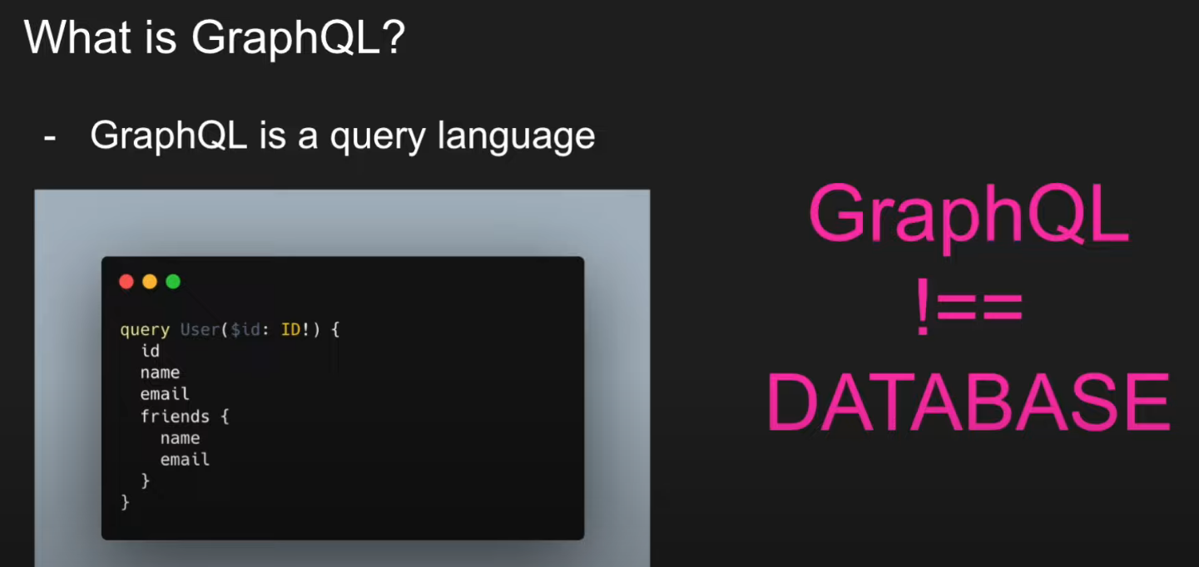

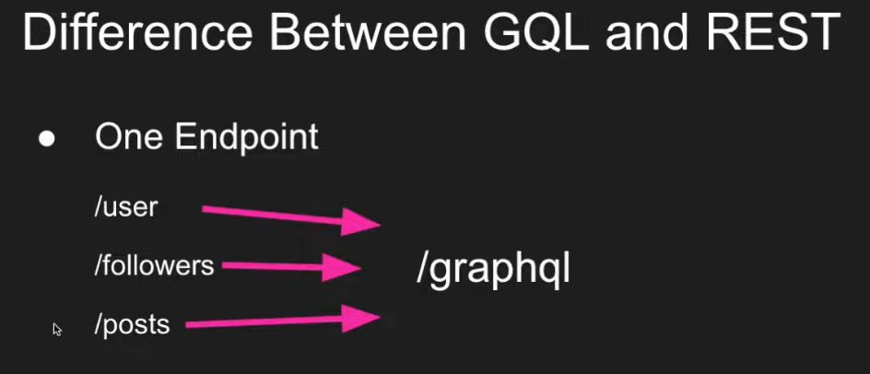

Hello,

I am excited to apply for the Backend Developer position at your esteemed organization.

I have 4+ years of experience in NodeJS, ExpressJS and MongoDB, I have read all 3 of these documentations from top to bottom and authored several small to huge codebases for defferent clients.

I have 3+ years experience working with AWS cloud and it’s products, I have included the detailed list of AWS services that I am familir with in my Resume.

I take pride in my commitment to delivering high-quality work, consistently meeting deadlines, and maintaining transparent communication with my clients. With my dedication and passion for development, I am confident in my ability to contribute significantly to your Sports Web app's success.

I am eager to discuss how my skills and expertise can elevate your project. I am available for a video interview. Moreover, I am willing to invest a minimum of 6+ hours per day and put in the extra effort required to meet project deadlines.

I am new to this platform, and I hope the lack of reviews and ratings would not hamper your decision-making process. Please give me a chance, and I won't let you down.

Warm Regards,

Sudeep.

***What are your weaknesses?***

I am meticulous and very attentive to details, so my weakness is that I sometimes need more time to perform tasks

***Share some examples of your failures***

So I was working for a small start up crm company and there were only 15 to 20 employees and the project manager started giving us lot of work to meet the deadlines and in that rush, I forgot one scenirio while writing validation code, so this code is responsible for validating whether the frontend is sending the valid data or not, so because of this bug, A bulk sms campaign went out to 3000 customers of one of our client, bcause of this error I learnt a lot…

***Can you describe a situation in which you tackled a particularly hard issue and were successful?***

Yes, In a previos company I was working for the main issue we faced was on how can we reduce the cloud costs we were racking up 1500 dollars per month… eventhough this task was not assigned to me, I was really curious about this issue and I went on this research rabbit hole and eventually I found out the bulk amount of the cost was due to unused resources and temporary resources that were not properly cleaned up

***What areas of your application are you strongest in***

I always excell in designing the architecture, I tend to go deep into what products and technologies should we use given the use case.

I excell at writing clean and highly efficient code

I am proud that I help my collegues